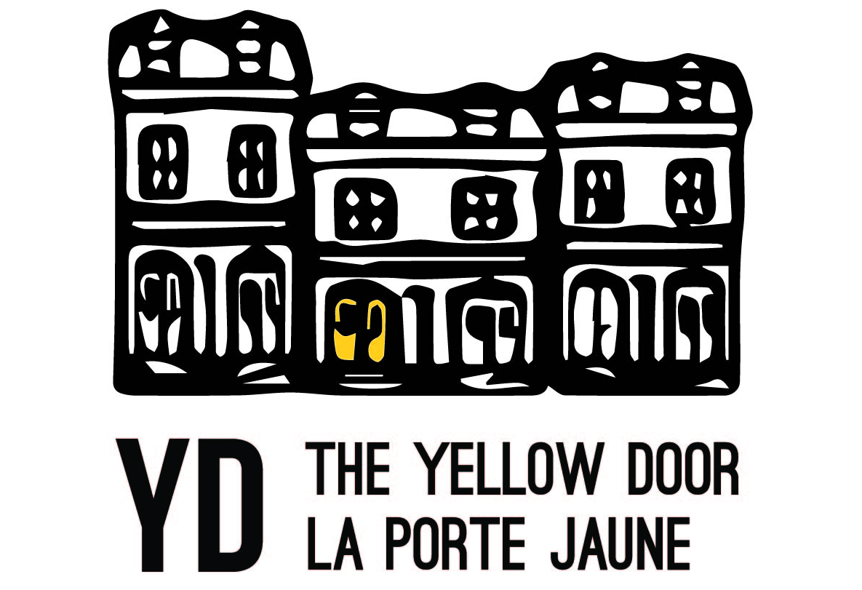

SPACE RENTAL PROPOSAL
Please complete all fields and return to info@yellowdoor.org.

Full Name(s) of the Event Organizer(s) (the person(s) responsible):
Organization:
Cell Phone: Email: @

Event Name:
Description:
Estimated Attendance:

Event Occurrence:
One-time Date Requested: Time: to
Monthly Start Date: End Date:
Occurring Every: Time: to
Weekly Start Date: End Date:
Occurring Every: Time: to
* Booked time will include your personal set-up, take-down and cleanup.
Room Request & Rates:
Community Room: 20 persons max capacity ($20/1 hour; $55/3hr event; $18/each extra hour)
Coffeehouse: 50 persons max capacity; includes kitchenette ($20/1 hour; $55/3hr event; $18/each extra hour)
Kitchen: 10 persons max capacity; includes all tools ($65/3hr minimum; $20/each extra hour)

Rental Equipment and Fees: Complimentary Amenities:
Refundable Cleaning Fee $25 Bathroom
Laptop and Projector $25 (optional) Wi-Fi (password required)
Microphones & Sound System $30 (optional)
* Equipment may only be rented Monday – Thursday.

Event proposals submitted less than 3 business days before proposed event date will not be considered. All rentals are subject to approval by the Executive Director. Once approved, you will receive an invoice via email – please note that reservations are not complete until payment is received in full.

For office use only
Date received: / Approved by YD Executive Director on

